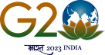
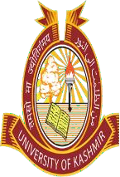
DIRECTORATE of ADMISSIONS and

COMPETITIVE EXAMINATIONS
University of Kashmir
NAAC Accredited Grade “ A+”

Extension Notice
PG Diploma, Diploma and Certificate Courses Session-2023
It is notified for information of all concerned that the date for submission of online Application Forms for PG Diploma, Diploma and Certificate Courses invited vide Admission Notification No. 4 of 2023 dated 23-03-2023 has been extended upto and including 26-05-2023.

No F (Date Extd.-PG Dip/Dip/Cert-2023) DACE/KU/23 Dated:- 23-05-2023
Sd/-
(Prof. M Farooq Mir)
Director (Directorate of Admissions & Competitive Examinations)

